**GHANA COMMUNICATION TECHNOLOGY UNIVERSITY**

**FACULTY OF COMPUTING AND INFORMATION SYSTEM.**

**BSc. INFORMATION TECHNOLOGY**

**SOFTWARE ENGINEERING**

**COURSE CODE: IT 305**

**GROUP MEMBERS**

1. Grace Atsu Abena Nukunu - 4211230023
2. Rahma Musah Hussein - 1703504597
3. Lord Amprofi - 4211231044
4. David Ansong Kwakye - 4211230216
5. Austin Quayson Nanabenyin - 4211231268

**Progress Report on Personal finance tracker**

1. **Product vision**

Our personal finance web application including features like expense tracking, budgeting, financial goal setting, and visual analytics. The primary goal of a personal finance app is to help users manage their financial resources effectively.

Objectives

A. Track Financial Transactions: Allow users to record income and expenses easily.

B. Budget Management: Enable users to create and monitor budgets for various spending categories.

C. Visual Insights: Provide charts and graphs for analyzing spending patterns and trends.

D. Goal Setting: Help users set and monitor progress toward financial goals like saving for a vacation or paying off debt.

E. Notifications: Remind users about bill payments or when they are close to exceeding a budget.

1. Features and descriptions

A. Income and Expense Tracking

Users can log their income and expenses manually.

Option to categorize transactions (e.g., food, rent, entertainment).

Attach notes or receipts to transactions.

B. Budget Management

Create monthly or custom budgets for specific categories.

Track real-time progress against set budgets.

Alerts for overspending in any category.

C. Savings Goals

Set and monitor financial goals (e.g., saving for a car, vacation).

Visual progress bars for each goal.

D. Analytics and Reports

Visual graphs to show spending trends, income distribution, and category breakdowns.

Periodic reports (e.g., weekly, monthly summaries).

E. Notifications and Reminders

Alerts for upcoming bills or recurring payments.

Tips and insights to improve financial health.

F. User Accounts and Security

Secure user authentication (e.g., email/password, social login).

Optional biometric login (fingerprint or face recognition).

Data encryption for financial safety.

1. Personas

A. Budget-Conscious Young Professional

Name: David Kwakye

Age: 21

Occupation: Marketing Specialist

Financial Goals: Save for a house, pay off student loans, and build an emergency fund.

Challenges:

Difficulty tracking spending habits across multiple categories.

Lack of clear progress toward financial goals.

Needs:

Easy-to-use budget tracking.

Reminders for bills and savings contributions.

Insights into spending habits through analytics.

B. Freelance Worker

Name: Grace Atsu

Age: 35

Occupation: Graphic Designer (freelancer)

Financial Goals: Manage irregular income and save for a long-term vacation.

Challenges:

Managing fluctuating monthly income.

Difficulty planning ahead due to inconsistent cash flow.

Needs:

Income tracking and categorization.

Ability to create flexible budgets based on income variability.

Alerts for irregular expenses or missed savings contributions.

C. Busy Parent

Name: Maria Lopez

Age: 42

Occupation: Teacher

Financial Goals: Save for children’s education and reduce household expenses.

Challenges:

Keeping track of multiple family-related expenses.

Lack of time to log transactions regularly.

Needs:

Intuitive interface with minimal manual entry.

Family expense tracking with categorized spending.

Quick insights into progress on saving for education goals.

1. User stories

A. As a user, I want to securely log into the app using my email and password so that my data remains private.

B. As a user, I want to enable biometric login (e.g., fingerprint or face ID) so that accessing the app is quick and secure.

C. As a user, I want to connect my bank account to the app so that my transactions sync automatically.

D. As a user, I want to create custom spending categories so that the app aligns with my unique financial needs.

E. As a user, I want to track my investments so that I can monitor all my finances in one place.

1. Scenarios

Scenario 1: Expense Tracking

User: David, a young professional

Situation: David goes out for lunch with colleagues and spends $15.

Action: She opens the app, selects the "Add Expense" option, inputs the amount, chooses the "Food" category, and saves it.

Outcome: The app updates her monthly expense report and shows her remaining budget for food.

Scenario 2: Budget Management

User: Grace, a busy parent

Situation: Grace wants to manage her monthly household expenses.

Action: She sets a $500 budget for groceries in the app at the start of the month.

Outcome: The app tracks all transactions categorized under "Groceries" and sends her an alert when she spends $450, reminding her to stay within budget.

Scenario 3: Savings Goal

User: Austin, a freelancer

Situation: Austin wants to save $3,000 for a vacation.

Action: He creates a savings goal in the app, setting the amount and timeline. The app calculates a monthly savings target and tracks his progress as he logs deposits.

Outcome: James sees a progress bar that motivates him to reach his goal.

Scenario 4: Analytics and Reports

User: Rahma, a young professional

Situation: At the end of the month, Rahma wants to review her spending habits.

Action: She opens the "Reports" section of the app, where she views pie charts and bar graphs showing how much she spent on food, rent, and entertainment.

Outcome: Sarah realizes she spent too much on dining out and decides to adjust her budget for the next month.

Scenario 5: Notifications and Reminders

User: Lord, a busy parent

Situation: Lord forgets about an upcoming electricity bill.

Action: The app sends her a reminder three days before the due date. She logs into her banking app and pays the bill on time.

Outcome: Lord avoids late fees and stays on track with her budget.

Scenario 6: Flexible Income Management

User: James, a freelancer

Situation: James receives a $2,000 payment for a project and wants to allocate it.

Action: He logs the payment as income, sets aside $500 for savings, $1,000 for bills, and $500 for discretionary spending.

Outcome: The app updates his financial overview and shows him how much of his income is left unallocated.

1. System Model Diagram

Use Case Diagram:

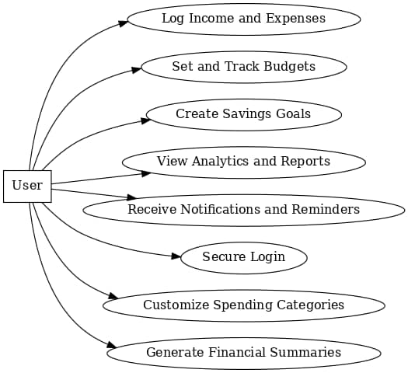

Sequence Diagram

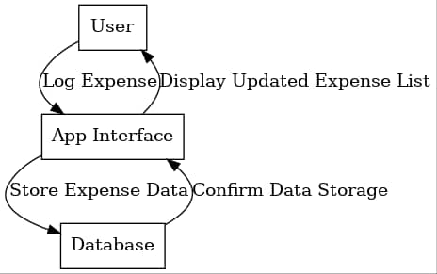

1. Individual Contributions
2. Grace Abena Atsu  
   - Overseeing the overall project and ensure tasks are completed on schedule.

* Coordinate team meetings and assign deadlines.
* Maintain communication between team members and ensure all parts integrate smoothly

1. Rahma Musah Hussein

* Design and develop the user interface (UI) of the app.
* Implement screens for features like logging transactions, viewing budgets, analytics.
* Ensure the app is responsive and user-friendly.

1. Lord Amprofi

* Develop and maintain the server-side logic for the app.
* Implement features like expense logging, budget management, and serving goal tracking.
* Handle data storage, retrieval, and integration with the database.

1. David Ansong Kwakye

* Design the database schema to store user data (e.g., transactions, budgets, goals).
* Ensure secure storage and efficient querying of data.
* Test the database for scalability and reliability.

1. Austin Quayson Nanabenyin

* Test the app to identify bugs and usability issues.
* Ensure the app meets performance, security, and functionality requirements.
* Provide feedback to developers and ensure fixes are implemented.

Challenges faced:

1. Data Security and Privacy

Challenge: Ensuring that users’ financial data is kept secure is a major concern. If your app handles sensitive information, such as bank account details or transaction history, it must be protected from breaches.

Solution: Implement encryption for sensitive data, use secure authentication methods (e.g., multi-factor authentication), and comply with data privacy regulations (e.g., GDPR).

2. Data Synchronization

Challenge: If your app integrates with external data sources (e.g., bank accounts), ensuring smooth synchronization of data can be tricky.

Solution: Use APIs that are reliable and well-documented. Implement a solid error-handling mechanism and allow users to manually refresh or update their data.

3. User Interface and Experience (UI/UX)

Challenge: Designing an intuitive and visually appealing interface that makes tracking finances easy can be difficult, especially for non-technical users.

Solution: Focus on simplicity and clarity. Conduct user testing to gather feedback on the app’s usability and make necessary adjustments. Provide helpful visualizations (charts, graphs) to make financial data more digestible.

Project repository link:

<https://github.com/r2d2web/Personal-Finance-Tracker->